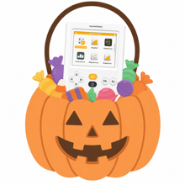

Where Can We Go Trick-or-Treating?
It’s Halloween! Time for Trick-or-Treat. In NumWorks Neighborhood, there are three large streets that surround the neighborhood. Beware of the Math Medic Mansion, which definitely (probably) isn't haunted. Mwah ha ha ha ha!

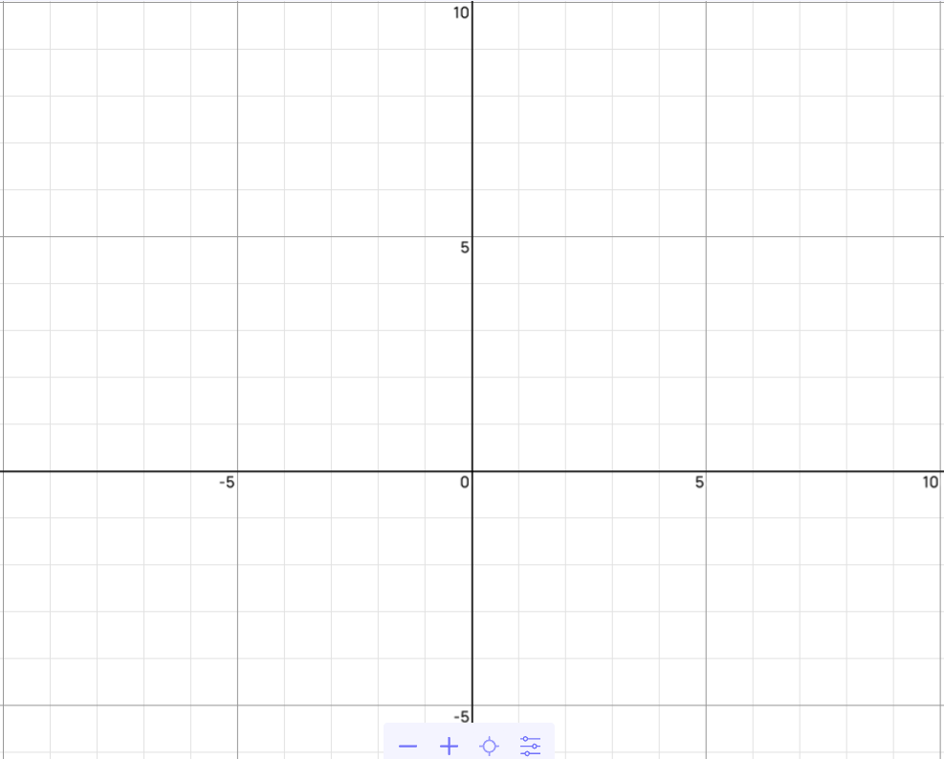
- Inside the neighborhood, streets are in a grid-pattern as shown. Graph and label each large street that surrounds the neighborhood on the coordinate plane:

Broomstick Boulevard:
  - $x =- 8$
Werewolf Way:
  - $y=\frac{1}{4}x-3$
Skeleton Street
  - $x+2y=8$

- Your house is located at the origin. Put a star there.
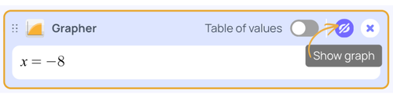
- Go to https://bit.ly/mm-numworks. Click the “Show graph” icon next to each card to check your work from #1.

- Use the board to identify the intersections of the 3 streets and label each with their ordered pairs. Then change the equations to inequalities so the overlapping region represents the neighborhood.

- The last card shows the restricted area around the Math Medic Mansion. Plot the restricted area on the coordinate plane.
  - The Math Medic Mansion is located at the center of the restricted area. What are the coordinates of the Math Medic Mansion?

  - If you go within a 2-block radius of the Math Medic Mansion, you’ll be stuck doing math problems for the rest of the night. Label the coordinates along Skeleton Street where you’ll have to walk around the restricted area to avoid that fate and shade the area where you can safely go trick-or-treating.

- Jack Skellington lives at (5, 2). Is his house in NumWorks Neighborhood? How do you know?

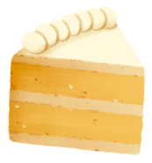

Will I Make a Profit?
You are making pumpkin chocolate chip cookies and pumpkin bars for a fall bake sale. You plan to sell the pumpkin chocolate chip cookies for $1 each and the pumpkin bars for $1.50 each. You want to earn a profit, so the revenue made by both products must be more than the $47.50 you spent on ingredients and packaging. You made a total of 72 cookies and 48 bars.

- If you sold 20 pumpkin chocolate chip cookies and 15 pumpkin bars, would you make a profit? Explain.

- If you only sold the pumpkin bars and no pumpkin chocolate chip cookies, could you make a profit? Explain.

- What is the maximum profit you could make at the fall bake sale? Explain.

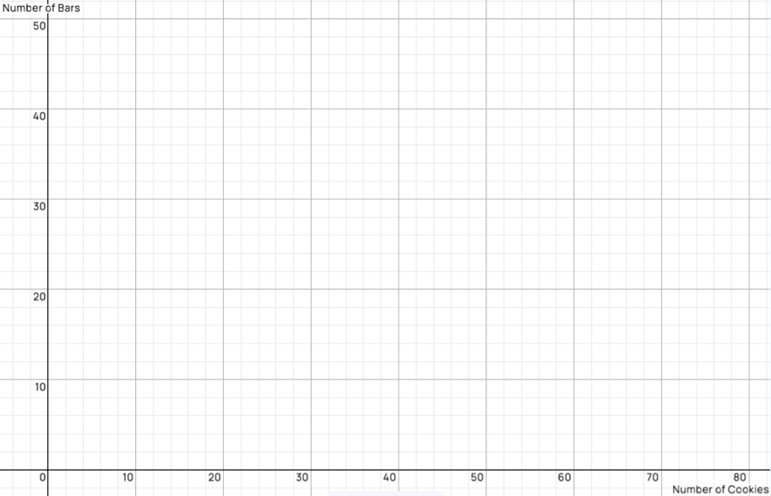
- Write a system of inequalities that would represent all possible combinations of pumpkin chocolate chip cookies and pumpkin bars you could sell at the bake sale and make a profit. Then, graph the system of inequalities on the coordinate plane provided.

- Tina loves thinking through financial planning and provides you with three possible sales that she believes will satisfy all your requirements. Determine whether Tina’s financial planning satisfies your goals. Explain.

- 10 pumpkin chocolate chip cookies and 25 pumpkin bars
- 40 pumpkin chocolate chip cookies and 10 pumpkin bars
- 5 pumpkin chocolate chip cookies and 25 pumpkin bars

- What are the benefits of using the graphed system of inequalities to answer question 5 rather than algebraically using the system of inequalities?

